**Functional Document**

|  |  |
| --- | --- |
| **Application** | NGERP - Centra |
| **Service Bundle** | Sales Management |
| **Service Request** | Multi VAT Transfer |

**Description :**

Multi VAT transfer screnn is used to process multiple undeclared invoice to declared invoice. Declared invoice is a formal procedure and undeclared invoice is not a formal procedure to process a invoice.

**Workflow Process :**

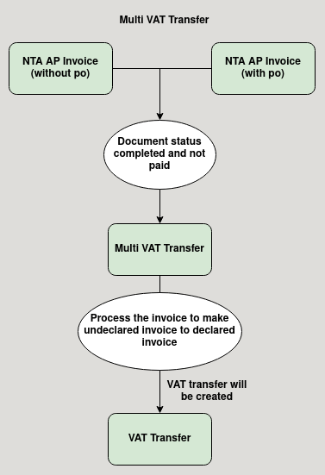

**Business Rules :**

* System only shows completed NTA AP invoice in multi VAT transfer screen
* Both invoice with purchase order and without purchase order will show in multi VAT transfer.
* Only invoice type undeclared is loaded in the multi VAT transfer form
* User should manually process the the invoice and the processed invoice will be chaged from undeclared to declared invoice and update in nta ap invoice screen vat invoice box.
* AP invoices which are already paid will not show in Multi VAT Transfer Screen, for them a VAT transfer will be created automatically.